ICPE Technical Staff
Parallel Sessions Instruction Sheet
This document outlines technical staff instructions for each session.
Emergency Contacts:
In case of anything happening that you need help for, please contact:
Thomas Dixon
Jacinta den Besten
Timeline and Runsheet
For each session you are allocated to, you will be given a run-sheet of who is to be presenting. It is not up to you to introduce speakers or ‘run’ the session, you are primarily there to share the pre-recorded videos, help the chair keep time, and manage any technical issues that come up.
Before the Session
You should arrive to the zoom meeting 15 minutes before it is scheduled to begin. You will have host access to the zoom meeting, so it will begin automatically when you click the link. If this does not happen, contact Tom Dixon ASAP. The emergency backup is to log in to the account that created the zoom meeting; all logins are in the ‘zoom links master’ spreadsheet.
Until the session is close to beginning, you should only admit chairs and presenters. The name (and registration number) of each host is in the runsheet for each meeting. It is preferable if each person changes their name to include their registration number – this will be communicated to them, but you will need to remind them.
You should make all presenters and chairs co-hosts by clicking on the option in the participants panel;
You should click the arrow next to the share screen button:
And make sure share screen is set to ‘host only’. This means that only you and the co-hosts can share screen.
You should introduce yourself to the chair, and say that you are going to be the technical support for the session. If possible, ask the presenters who are presenting live to check that they can share-screen correctly.
You should also check that the meeting is recording: you can see this by there being a little recording symbol in the top corner of the zoom call;
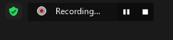
You should set the ‘zoom whiteboard’ setting:
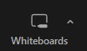
To ‘host only’ can share;
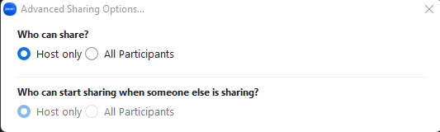
Close to 5 minutes before the session begins, you can start admitting people in the waiting room. They should have their name and registration number in their zoom name. Ideally, you should cross-reference this against the master list of attendees. Admit all who seem to match, and message any who do not have their name correct to please update their registration name. (Note: this is less important than ensuring the smooth running of the conference!)
Before or during the session please check on the poster platform: https://icpe2022.virtualpostersession.org/ if any questions have been asked about talks in this session. If they have post them in chat during the session so that the chair can ask the presenters if they judge it to be a good question.
During the Session
You should be keeping an eye on the participants list, and letting people in as they arrive. If a lot of people have not changed their zoom names to match the list please post in chat asking everyone to change their zoom names to the one emailed to them for the conference.
You are responsible for timing the talks and announcing in the chat how much time there is left. For keynotes, the time is 20 minutes, and you should give a 5, 3 and 1 minute remaining warning in the “everyone” chat, 15 minute in, 17 minutes in and 19 minutes in. There is then 5 minutes for questions. For other talks, the time is 10 minutes, and you should give a 3 and 1 minute remining warning in the “everyone” chat, 7 minutes and 9 minutes in. The question section for contributed talks is at the end of the session.
You will need to screenshare and show the YouTube videos for the asynchronous talks. The links and their position in the session are in each session’s run-sheet. Please see below for the process on sharing the YouTube videos. Please post the link to the video in chat when you start sharing it so that participants can open it on their machine if desired.
If someone attempts to interrupt the speakers, please mute them and send them a private message to let them know that question times are at the end of the entire session (or at the end of the keynote).
Please take a screenshot of the attendees list and upload it to the ‘attendee screenshots’ folder on the one-drive. Name it after the session you were in.
After the Session
When time is up post in chat that you are ending the recording. End the recording and then post in chat that you are now leaving but that they are welcome to continue their discussion. Then you can leave the room. When you click the ‘end’ button in the bottom left, make sure to hit ‘leave meeting’ NOT ‘end meeting for all!’. Then, assign a new host (the chair or one of the presenters will do) and leave the meeting;

Common Issues / How to Do Things
Screensharing a youtube video
When screensharing a youtube video, have the video running and click share-screen, then select the chrome tab that the video is running in. Make sure you click the ‘share sound’ and ‘optimise for video’ buttons, before hitting share.
There are two ways to handle screensharing, depending on if you have one or two monitors:
Two monitor setups: place the youtube window on one monitor, full screen, and place all your other zoom items on the other screen. This is important as the screen-shared video will have grey boxes covering it if anything is on your screen covering the video.
Single monitor setups: Resize the youtube window to be a medium portion of the screen (Use chrome if you are on the UNSW provided machines, and you should have nothing else on the chrome tab)
Click the two-arrows next to the gear to make it “full width” (this is using a chrome extension: https://chrome.google.com/webstore/detail/youtube-windowed-fullscre/gkkmiofalnjagdcjheckamobghglpdpm?hl=en which is already on the ICPE computers)
And then screenshare the chrome window. YOU SHOULD MAKE SURE TO CLICK “SHARE SOUND” AND “OPTIMISE FOR VIDEO” You should drag the zoom-bar to the bottom of the screen and put the participants and chat to the side:

Allowing others to screenshare
If someone says they cannot screenshare, first check that they are a co-host and make them one if not. Otherwise, you can check the arrow on the top right of the ‘share screen’ button:
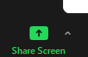
Click ‘advanced screensharing options’ and then
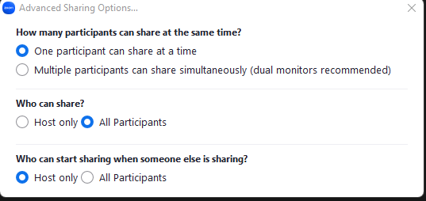
Make sure ‘all participants can share’ is checked. This will allow EVERYONE to screenshare.
Waiting Room Admissions
People in the waiting room show up in a little pop-up at the top of the window;
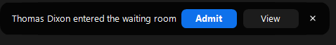
Or as a section in the participants list.
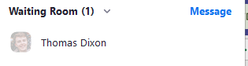
There will be a master list of attendees that you should consult, and only let people in who match. You can alternately let them in but message them (privately) to get them to change their name.
Screensharing YouTube Videos
The exact process for this needs to be worked out!
Muting other participants, kicking them or changing their name.
If someone is unmuted and needs to be muted, you can find them in the participants list and hit the mute button;
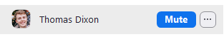
Usually it will be easy to tell if someone is talking as they will have a microphone that is not red:

(Note here that I did not have my camera on, so the camera is red).
The ‘…’ button has a few useful extras;
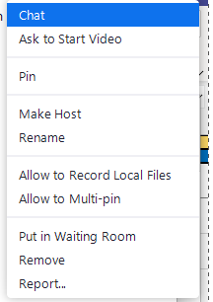
“Chat” will let you start a private chat
“Rename” will let you rename them
“Remove” will boot them from the meeting.

